**Ministerul Educației, Culturii și Cercetării**

**Universitatea Tehnică a Moldovei**

**Facultatea Calculatoare, Informatică și Microelectronică**

**Departamentul Ingineria Software și Automatică**

**Raport**

Lucrarea de laborator nr.7

Disciplina: Programarea pilotată de evenimente.

Tema: Limbajul de programare C#, .NET frameworkul pentru Windows.

**Efectuat**: st.gr. TI-207 Bunescu Gabriel.

**Verificat**: asist. univ. Gaidarji Alina

Chișinău 2022

**Scopul lucrării:**

* studierea limbajului C#;
* studierea .NET frameworkul pentru Windows,;
* studierea relației dintre C# și arhitectura .Net.

**Sarcina:**

Scrieţi un program care afişează un test, utilizând radio butoane, check boxes, butoane push și pentru cronometrare de folosit timer-ul. Pentru afișarea rezultatelor desenați un grafic în dependență de răspunsuri sau timp.

**Codul sursă:**

**Form1.cs**

using System;

using System.Collections.Generic;

using System.ComponentModel;

using System.Data;

using System.Drawing;

using System.Linq;

using System.Text;

using System.Threading.Tasks;

using System.Windows.Forms;

namespace WindowsFormsApp

{

public partial class Form1 : Form

{

int timeleft = 60;

int quiz, punct, nota;

private void label_Click(object sender, EventArgs e)

{

}

public Form1()

{

InitializeComponent();

startb.Visible = true;

label.Visible = true;

nextb.Visible = false;

label1.Visible = false;

label2.Visible = false;

label3.Visible = false;

label4.Visible = false;

label5.Visible = false;

label6.Visible = false;

prevb.Visible = false;

finishb.Visible = false;

againb.Visible = false;

chart1.Visible = false;

chart1.Series["Raspuns"].IsVisibleInLegend = false;

chart1.ChartAreas[0].BackColor = Color.Transparent;

labelnota.Visible = false;

labeltrue.Visible = false;

labelfalse.Visible = false;

radioButton1.Visible = false;

radioButton2.Visible = false;

radioButton3.Visible = false;

checkBox1.Visible = false;

checkBox2.Visible = false;

checkBox3.Visible = false;

checkBox4.Visible = false;

checkBox5.Visible = false;

checkBox6.Visible = false;

numericUpDown1.Visible = false;

numericUpDown2.Visible = false;

}

private void nextb_Click(object sender, EventArgs e)

{

if (quiz == 1)

{

quiz++;

prevb.Visible = true;

label2.Visible = false;

radioButton1.Visible = false;

radioButton2.Visible = false;

radioButton3.Visible = false;

label3.Visible = true;

checkBox1.Visible = true;

checkBox2.Visible = true;

checkBox3.Visible = true;

checkBox4.Visible = true;

checkBox5.Visible = true;

checkBox6.Visible = true;

}

else

{

if (quiz == 2)

{

quiz++;

label3.Visible = false;

checkBox1.Visible = false;

checkBox2.Visible = false;

checkBox3.Visible = false;

checkBox4.Visible = false;

checkBox5.Visible = false;

checkBox6.Visible = false;

label4.Visible = true;

label5.Visible = true;

label6.Visible = true;

numericUpDown1.Visible = true;

numericUpDown2.Visible = true;

nextb.Visible = false;

finishb.Visible = true;

}

}

}

private void timer1_Tick(object sender, EventArgs e)

{

if (timeleft > 0)

{

timeleft = timeleft - 1;

label1.Text = "Timpul: " + Convert.ToString(timeleft) + " secunde";

}

else

{

timer1.Stop();

}

}

private void label1_Click(object sender, EventArgs e)

{

}

private void label2_Click(object sender, EventArgs e)

{

}

private void prevb_Click(object sender, EventArgs e)

{

if (quiz == 2)

{

quiz--;

prevb.Visible = false;

label2.Visible = true;

radioButton1.Visible = true;

radioButton2.Visible = true;

radioButton3.Visible = true;

label3.Visible = false;

checkBox1.Visible = false;

checkBox2.Visible = false;

checkBox3.Visible = false;

checkBox4.Visible = false;

checkBox5.Visible = false;

checkBox6.Visible = false;

}

else

{

if (quiz == 3)

{

quiz--;

label4.Visible = false;

label5.Visible = false;

label6.Visible = false;

numericUpDown1.Visible = false;

numericUpDown2.Visible = false;

label3.Visible = true;

checkBox1.Visible = true;

checkBox2.Visible = true;

checkBox3.Visible = true;

checkBox4.Visible = true;

checkBox5.Visible = true;

checkBox6.Visible = true;

nextb.Visible = true;

finishb.Visible = false;

}

}

}

private void label3_Click(object sender, EventArgs e)

{

}

private void checkBox3_CheckedChanged(object sender, EventArgs e)

{

}

private void finishb_Click(object sender, EventArgs e)

{

timer1.Stop();

if (radioButton3.Checked) punct++;

if (checkBox2.Checked) punct++;

if (checkBox3.Checked) punct++;

if (numericUpDown1.Value == 8) punct++;

if (numericUpDown2.Value == 9) punct++;

label4.Visible = false;

label5.Visible = false;

label6.Visible = false;

numericUpDown1.Visible = false;

numericUpDown2.Visible = false;

chart1.Series["Raspuns"].Points.AddXY("Corecte", punct);

chart1.Series["Raspuns"].Points[0].Color = Color.Green;

chart1.Series["Raspuns"].Points.AddXY("Gresite", 5 - punct);

chart1.Series["Raspuns"].Points[1].Color = Color.Red;

chart1.Visible = true;

prevb.Visible = false;

finishb.Visible = false;

label1.Location = new Point(122, 216);

label1.Text = "Timpul ramas: " + Convert.ToString(timeleft) + " secunde";

nota = punct * 2;

labelnota.Visible = true;

labeltrue.Visible = true;

labelfalse.Visible = true;

labelnota.Text = "Nota: " + Convert.ToString(nota);

labeltrue.Text = "Corecte: " + Convert.ToString(punct);

labelfalse.Text = "Gresite: " + Convert.ToString(5 - punct);

againb.Visible = true;

}

private void againb_Click(object sender, EventArgs e)

{

startb.Visible = true;

label.Visible = true;

againb.Visible = false;

labelnota.Visible = false;

labeltrue.Visible = false;

labelfalse.Visible = false;

label1.Visible = false;

chart1.Visible = false;

chart1.Series[0].Points.Clear();

}

private void Form1_Load(object sender, EventArgs e)

{

}

private void startb_Click(object sender, EventArgs e)

{

radioButton1.Visible = true;

radioButton2.Visible = true;

radioButton3.Visible = true;

numericUpDown1.Value = 0;

numericUpDown2.Value = 0;

label1.Location = new Point(12, 9);

label1.Text = "Timpul: 60 secunde";

label1.Visible = true;

label2.Visible = true;

label3.Visible = false;

punct = 0;

timeleft = 60;

timer1.Start();

label.Visible = false;

startb.Visible = false;

nextb.Visible = true;

quiz = 1;

}

}

}

**Form1.Designer.cs:**

namespace WindowsFormsApp

{

partial class Form1

{

/// <summary>

/// Required designer variable.

/// </summary>

private System.ComponentModel.IContainer components = null;

/// <summary>

/// Clean up any resources being used.

/// </summary>

/// <param name="disposing">true if managed resources should be disposed; otherwise, false.</param>

protected override void Dispose(bool disposing)

{

if (disposing && (components != null))

{

components.Dispose();

}

base.Dispose(disposing);

}

#region Windows Form Designer generated code

/// <summary>

/// Required method for Designer support - do not modify

/// the contents of this method with the code editor.

/// </summary>

private void InitializeComponent()

{

this.components = new System.ComponentModel.Container();

System.Windows.Forms.DataVisualization.Charting.ChartArea chartArea1 = new System.Windows.Forms.DataVisualization.Charting.ChartArea();

System.Windows.Forms.DataVisualization.Charting.Legend legend1 = new System.Windows.Forms.DataVisualization.Charting.Legend();

System.Windows.Forms.DataVisualization.Charting.Series series1 = new System.Windows.Forms.DataVisualization.Charting.Series();

this.startb = new System.Windows.Forms.Button();

this.label = new System.Windows.Forms.Label();

this.nextb = new System.Windows.Forms.Button();

this.timer1 = new System.Windows.Forms.Timer(this.components);

this.label1 = new System.Windows.Forms.Label();

this.label2 = new System.Windows.Forms.Label();

this.radioButton1 = new System.Windows.Forms.RadioButton();

this.radioButton2 = new System.Windows.Forms.RadioButton();

this.radioButton3 = new System.Windows.Forms.RadioButton();

this.prevb = new System.Windows.Forms.Button();

this.label3 = new System.Windows.Forms.Label();

this.checkBox1 = new System.Windows.Forms.CheckBox();

this.checkBox2 = new System.Windows.Forms.CheckBox();

this.checkBox3 = new System.Windows.Forms.CheckBox();

this.checkBox4 = new System.Windows.Forms.CheckBox();

this.checkBox5 = new System.Windows.Forms.CheckBox();

this.checkBox6 = new System.Windows.Forms.CheckBox();

this.label4 = new System.Windows.Forms.Label();

this.numericUpDown1 = new System.Windows.Forms.NumericUpDown();

this.numericUpDown2 = new System.Windows.Forms.NumericUpDown();

this.label5 = new System.Windows.Forms.Label();

this.label6 = new System.Windows.Forms.Label();

this.finishb = new System.Windows.Forms.Button();

this.againb = new System.Windows.Forms.Button();

this.labelnota = new System.Windows.Forms.Label();

this.labeltrue = new System.Windows.Forms.Label();

this.labelfalse = new System.Windows.Forms.Label();

this.chart1 = new System.Windows.Forms.DataVisualization.Charting.Chart();

((System.ComponentModel.ISupportInitialize)(this.numericUpDown1)).BeginInit();

((System.ComponentModel.ISupportInitialize)(this.numericUpDown2)).BeginInit();

((System.ComponentModel.ISupportInitialize)(this.chart1)).BeginInit();

this.SuspendLayout();

//

// startb

//

this.startb.Font = new System.Drawing.Font("Arial Narrow", 27.75F, System.Drawing.FontStyle.Bold);

this.startb.Location = new System.Drawing.Point(279, 173);

this.startb.Name = "startb";

this.startb.Size = new System.Drawing.Size(237, 83);

this.startb.TabIndex = 15;

this.startb.Text = "Incepe";

this.startb.UseVisualStyleBackColor = true;

this.startb.Click += new System.EventHandler(this.startb_Click);

//

// label

//

this.label.AutoSize = true;

this.label.Font = new System.Drawing.Font("Arial Narrow", 20.25F, System.Drawing.FontStyle.Bold);

this.label.Location = new System.Drawing.Point(196, 259);

this.label.Name = "label";

this.label.Size = new System.Drawing.Size(413, 49);

this.label.TabIndex = 2;

this.label.Text = "Timp la dispozitie: 1 min";

this.label.Click += new System.EventHandler(this.label_Click);

//

// nextb

//

this.nextb.Font = new System.Drawing.Font("Arial Narrow", 12F);

this.nextb.Location = new System.Drawing.Point(632, 375);

this.nextb.Name = "nextb";

this.nextb.Size = new System.Drawing.Size(139, 51);

this.nextb.TabIndex = 4;

this.nextb.Text = "Urmatorul >";

this.nextb.UseVisualStyleBackColor = true;

this.nextb.Click += new System.EventHandler(this.nextb_Click);

//

// timer1

//

this.timer1.Interval = 1000;

this.timer1.Tick += new System.EventHandler(this.timer1_Tick);

//

// label1

//

this.label1.AutoSize = true;

this.label1.Font = new System.Drawing.Font("Palatino Linotype", 12F);

this.label1.Location = new System.Drawing.Point(29, 30);

this.label1.Name = "label1";

this.label1.Size = new System.Drawing.Size(217, 32);

this.label1.TabIndex = 5;

this.label1.Text = "Timpul: 60 secunde";

this.label1.Click += new System.EventHandler(this.label1_Click);

//

// label2

//

this.label2.AutoSize = true;

this.label2.Font = new System.Drawing.Font("Arial Narrow", 20.25F, System.Drawing.FontStyle.Bold);

this.label2.Location = new System.Drawing.Point(171, 121);

this.label2.Name = "label2";

this.label2.Size = new System.Drawing.Size(490, 49);

this.label2.TabIndex = 6;

this.label2.Text = "Cum se numeste facultatea ?";

this.label2.Click += new System.EventHandler(this.label2_Click);

//

// radioButton1

//

this.radioButton1.AutoSize = true;

this.radioButton1.Font = new System.Drawing.Font("Arial Narrow", 13F);

this.radioButton1.Location = new System.Drawing.Point(88, 193);

this.radioButton1.Name = "radioButton1";

this.radioButton1.Size = new System.Drawing.Size(81, 35);

this.radioButton1.TabIndex = 5;

this.radioButton1.TabStop = true;

this.radioButton1.Text = "FUA";

this.radioButton1.UseVisualStyleBackColor = true;

//

// radioButton2

//

this.radioButton2.AutoSize = true;

this.radioButton2.Font = new System.Drawing.Font("Arial Narrow", 13F);

this.radioButton2.Location = new System.Drawing.Point(314, 193);

this.radioButton2.Name = "radioButton2";

this.radioButton2.Size = new System.Drawing.Size(85, 35);

this.radioButton2.TabIndex = 6;

this.radioButton2.TabStop = true;

this.radioButton2.Text = "FEIE";

this.radioButton2.UseVisualStyleBackColor = true;

//

// radioButton3

//

this.radioButton3.AutoSize = true;

this.radioButton3.Font = new System.Drawing.Font("Arial Narrow", 13F);

this.radioButton3.Location = new System.Drawing.Point(545, 193);

this.radioButton3.Name = "radioButton3";

this.radioButton3.Size = new System.Drawing.Size(90, 35);

this.radioButton3.TabIndex = 7;

this.radioButton3.TabStop = true;

this.radioButton3.Text = "FCIM";

this.radioButton3.UseVisualStyleBackColor = true;

//

// prevb

//

this.prevb.Font = new System.Drawing.Font("Arial Narrow", 12F);

this.prevb.Location = new System.Drawing.Point(74, 375);

this.prevb.Name = "prevb";

this.prevb.Size = new System.Drawing.Size(172, 51);

this.prevb.TabIndex = 8;

this.prevb.Text = "< Precedentul";

this.prevb.UseVisualStyleBackColor = true;

this.prevb.Click += new System.EventHandler(this.prevb_Click);

//

// label3

//

this.label3.AutoSize = true;

this.label3.Font = new System.Drawing.Font("Arial Narrow", 20.25F, System.Drawing.FontStyle.Bold);

this.label3.Location = new System.Drawing.Point(171, 98);

this.label3.Name = "label3";

this.label3.Size = new System.Drawing.Size(435, 49);

this.label3.TabIndex = 9;

this.label3.Text = "Care camine au 12 etaje ?";

this.label3.Click += new System.EventHandler(this.label3_Click);

//

// checkBox1

//

this.checkBox1.AutoSize = true;

this.checkBox1.Font = new System.Drawing.Font("Arial Narrow", 18F);

this.checkBox1.Location = new System.Drawing.Point(130, 165);

this.checkBox1.Name = "checkBox1";

this.checkBox1.Size = new System.Drawing.Size(76, 46);

this.checkBox1.TabIndex = 10;

this.checkBox1.Text = "12";

this.checkBox1.UseVisualStyleBackColor = true;

//

// checkBox2

//

this.checkBox2.AutoSize = true;

this.checkBox2.Font = new System.Drawing.Font("Arial Narrow", 18F);

this.checkBox2.Location = new System.Drawing.Point(130, 299);

this.checkBox2.Name = "checkBox2";

this.checkBox2.Size = new System.Drawing.Size(60, 46);

this.checkBox2.TabIndex = 11;

this.checkBox2.Text = "1";

this.checkBox2.UseVisualStyleBackColor = true;

//

// checkBox3

//

this.checkBox3.AutoSize = true;

this.checkBox3.Font = new System.Drawing.Font("Arial Narrow", 18F);

this.checkBox3.Location = new System.Drawing.Point(344, 164);

this.checkBox3.Name = "checkBox3";

this.checkBox3.Size = new System.Drawing.Size(60, 46);

this.checkBox3.TabIndex = 12;

this.checkBox3.Text = "2";

this.checkBox3.UseVisualStyleBackColor = true;

this.checkBox3.CheckedChanged += new System.EventHandler(this.checkBox3_CheckedChanged);

//

// checkBox4

//

this.checkBox4.AutoSize = true;

this.checkBox4.Font = new System.Drawing.Font("Arial Narrow", 18F);

this.checkBox4.Location = new System.Drawing.Point(344, 298);

this.checkBox4.Name = "checkBox4";

this.checkBox4.Size = new System.Drawing.Size(76, 46);

this.checkBox4.TabIndex = 13;

this.checkBox4.Text = "11";

this.checkBox4.UseVisualStyleBackColor = true;

//

// checkBox5

//

this.checkBox5.AutoSize = true;

this.checkBox5.Font = new System.Drawing.Font("Arial Narrow", 18F);

this.checkBox5.Location = new System.Drawing.Point(578, 163);

this.checkBox5.Name = "checkBox5";

this.checkBox5.Size = new System.Drawing.Size(76, 46);

this.checkBox5.TabIndex = 14;

this.checkBox5.Text = "10";

this.checkBox5.UseVisualStyleBackColor = true;

//

// checkBox6

//

this.checkBox6.AutoSize = true;

this.checkBox6.Font = new System.Drawing.Font("Arial Narrow", 18F);

this.checkBox6.Location = new System.Drawing.Point(578, 299);

this.checkBox6.Name = "checkBox6";

this.checkBox6.Size = new System.Drawing.Size(76, 46);

this.checkBox6.TabIndex = 15;

this.checkBox6.Text = "13";

this.checkBox6.UseVisualStyleBackColor = true;

//

// label4

//

this.label4.AutoSize = true;

this.label4.Font = new System.Drawing.Font("Arial Narrow", 20.25F, System.Drawing.FontStyle.Bold);

this.label4.Location = new System.Drawing.Point(282, 78);

this.label4.Name = "label4";

this.label4.Size = new System.Drawing.Size(182, 49);

this.label4.TabIndex = 16;

this.label4.Text = "Calculatii:";

//

// numericUpDown1

//

this.numericUpDown1.Font = new System.Drawing.Font("Arial Narrow", 14.25F);

this.numericUpDown1.Location = new System.Drawing.Point(328, 179);

this.numericUpDown1.Name = "numericUpDown1";

this.numericUpDown1.Size = new System.Drawing.Size(120, 40);

this.numericUpDown1.TabIndex = 17;

//

// numericUpDown2

//

this.numericUpDown2.Font = new System.Drawing.Font("Arial Narrow", 14.25F);

this.numericUpDown2.Location = new System.Drawing.Point(328, 234);

this.numericUpDown2.Name = "numericUpDown2";

this.numericUpDown2.Size = new System.Drawing.Size(120, 40);

this.numericUpDown2.TabIndex = 18;

//

// label5

//

this.label5.AutoSize = true;

this.label5.Font = new System.Drawing.Font("Arial Narrow", 20.25F, System.Drawing.FontStyle.Bold);

this.label5.Location = new System.Drawing.Point(190, 170);

this.label5.Name = "label5";

this.label5.Size = new System.Drawing.Size(132, 49);

this.label5.TabIndex = 19;

this.label5.Text = "2+2*2=";

//

// label6

//

this.label6.AutoSize = true;

this.label6.Font = new System.Drawing.Font("Arial Narrow", 20.25F, System.Drawing.FontStyle.Bold);

this.label6.Location = new System.Drawing.Point(222, 230);

this.label6.Name = "label6";

this.label6.Size = new System.Drawing.Size(100, 49);

this.label6.TabIndex = 20;

this.label6.Text = "3^2=";

//

// finishb

//

this.finishb.Font = new System.Drawing.Font("Arial Narrow", 15.75F, System.Drawing.FontStyle.Bold);

this.finishb.Location = new System.Drawing.Point(632, 375);

this.finishb.Name = "finishb";

this.finishb.Size = new System.Drawing.Size(139, 51);

this.finishb.TabIndex = 21;

this.finishb.Text = "Finish";

this.finishb.UseVisualStyleBackColor = true;

this.finishb.Click += new System.EventHandler(this.finishb_Click);

//

// againb

//

this.againb.Font = new System.Drawing.Font("Arial Narrow", 15.75F, System.Drawing.FontStyle.Bold);

this.againb.Location = new System.Drawing.Point(316, 375);

this.againb.Name = "againb";

this.againb.Size = new System.Drawing.Size(172, 51);

this.againb.TabIndex = 22;

this.againb.Text = "Din nou ?";

this.againb.UseVisualStyleBackColor = true;

this.againb.Click += new System.EventHandler(this.againb_Click);

//

// labelnota

//

this.labelnota.AutoSize = true;

this.labelnota.Font = new System.Drawing.Font("Arial Narrow", 20.25F, System.Drawing.FontStyle.Bold);

this.labelnota.Location = new System.Drawing.Point(145, 117);

this.labelnota.Name = "labelnota";

this.labelnota.Size = new System.Drawing.Size(97, 49);

this.labelnota.TabIndex = 23;

this.labelnota.Text = "Nota";

//

// labeltrue

//

this.labeltrue.AutoSize = true;

this.labeltrue.Font = new System.Drawing.Font("Arial Narrow", 18F, System.Drawing.FontStyle.Bold);

this.labeltrue.ForeColor = System.Drawing.Color.FromArgb(((int)(((byte)(0)))), ((int)(((byte)(192)))), ((int)(((byte)(0)))));

this.labeltrue.Location = new System.Drawing.Point(143, 185);

this.labeltrue.Name = "labeltrue";

this.labeltrue.Size = new System.Drawing.Size(110, 42);

this.labeltrue.TabIndex = 24;

this.labeltrue.Text = "Corect";

//

// labelfalse

//

this.labelfalse.AutoSize = true;

this.labelfalse.Font = new System.Drawing.Font("Arial Narrow", 18F, System.Drawing.FontStyle.Bold);

this.labelfalse.ForeColor = System.Drawing.Color.FromArgb(((int)(((byte)(192)))), ((int)(((byte)(0)))), ((int)(((byte)(0)))));

this.labelfalse.Location = new System.Drawing.Point(147, 259);

this.labelfalse.Name = "labelfalse";

this.labelfalse.Size = new System.Drawing.Size(102, 42);

this.labelfalse.TabIndex = 25;

this.labelfalse.Text = "Gresit";

//

// chart1

//

this.chart1.BackColor = System.Drawing.Color.Transparent;

this.chart1.BorderlineColor = System.Drawing.Color.Transparent;

chartArea1.Name = "ChartArea1";

this.chart1.ChartAreas.Add(chartArea1);

legend1.Name = "Legend1";

this.chart1.Legends.Add(legend1);

this.chart1.Location = new System.Drawing.Point(503, 30);

this.chart1.Name = "chart1";

series1.ChartArea = "ChartArea1";

series1.ChartType = System.Windows.Forms.DataVisualization.Charting.SeriesChartType.Doughnut;

series1.Legend = "Legend1";

series1.LegendText = "Raspuns";

series1.Name = "Raspuns";

this.chart1.Series.Add(series1);

this.chart1.Size = new System.Drawing.Size(256, 261);

this.chart1.TabIndex = 40;

this.chart1.Text = "Raspuns";

//

// Form1

//

this.AutoScaleDimensions = new System.Drawing.SizeF(9F, 20F);

this.AutoScaleMode = System.Windows.Forms.AutoScaleMode.Font;

this.ClientSize = new System.Drawing.Size(800, 450);

this.Controls.Add(this.chart1);

this.Controls.Add(this.labelfalse);

this.Controls.Add(this.labeltrue);

this.Controls.Add(this.labelnota);

this.Controls.Add(this.againb);

this.Controls.Add(this.finishb);

this.Controls.Add(this.label6);

this.Controls.Add(this.label5);

this.Controls.Add(this.numericUpDown2);

this.Controls.Add(this.numericUpDown1);

this.Controls.Add(this.label4);

this.Controls.Add(this.checkBox6);

this.Controls.Add(this.checkBox5);

this.Controls.Add(this.checkBox4);

this.Controls.Add(this.checkBox3);

this.Controls.Add(this.checkBox2);

this.Controls.Add(this.checkBox1);

this.Controls.Add(this.label3);

this.Controls.Add(this.prevb);

this.Controls.Add(this.radioButton3);

this.Controls.Add(this.radioButton2);

this.Controls.Add(this.radioButton1);

this.Controls.Add(this.label2);

this.Controls.Add(this.label1);

this.Controls.Add(this.nextb);

this.Controls.Add(this.label);

this.Controls.Add(this.startb);

this.Name = "Form1";

this.Text = "Lab-7 Bunescu Gabriel TI-207";

this.Load += new System.EventHandler(this.Form1_Load);

((System.ComponentModel.ISupportInitialize)(this.numericUpDown1)).EndInit();

((System.ComponentModel.ISupportInitialize)(this.numericUpDown2)).EndInit();

((System.ComponentModel.ISupportInitialize)(this.chart1)).EndInit();

this.ResumeLayout(false);

this.PerformLayout();

}

#endregion

private System.Windows.Forms.Button startb;

private System.Windows.Forms.Label label;

private System.Windows.Forms.Button nextb;

private System.Windows.Forms.Timer timer1;

private System.Windows.Forms.Label label1;

private System.Windows.Forms.Label label2;

private System.Windows.Forms.RadioButton radioButton1;

private System.Windows.Forms.RadioButton radioButton2;

private System.Windows.Forms.RadioButton radioButton3;

private System.Windows.Forms.Button prevb;

private System.Windows.Forms.Label label3;

private System.Windows.Forms.CheckBox checkBox1;

private System.Windows.Forms.CheckBox checkBox2;

private System.Windows.Forms.CheckBox checkBox3;

private System.Windows.Forms.CheckBox checkBox4;

private System.Windows.Forms.CheckBox checkBox5;

private System.Windows.Forms.CheckBox checkBox6;

private System.Windows.Forms.Label label4;

private System.Windows.Forms.NumericUpDown numericUpDown1;

private System.Windows.Forms.NumericUpDown numericUpDown2;

private System.Windows.Forms.Label label5;

private System.Windows.Forms.Label label6;

private System.Windows.Forms.Button finishb;

private System.Windows.Forms.Button againb;

private System.Windows.Forms.Label labelnota;

private System.Windows.Forms.Label labeltrue;

private System.Windows.Forms.Label labelfalse;

private System.Windows.Forms.DataVisualization.Charting.Chart chart1;

}

}

**Rezultatul execuției:**

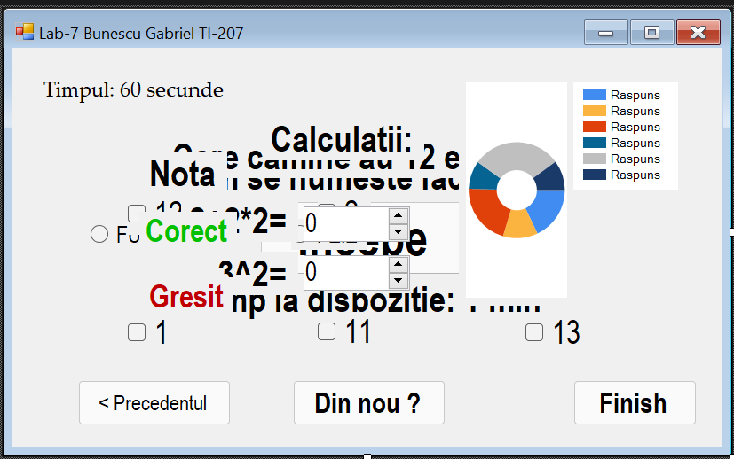

Figura 1. Form1.cs

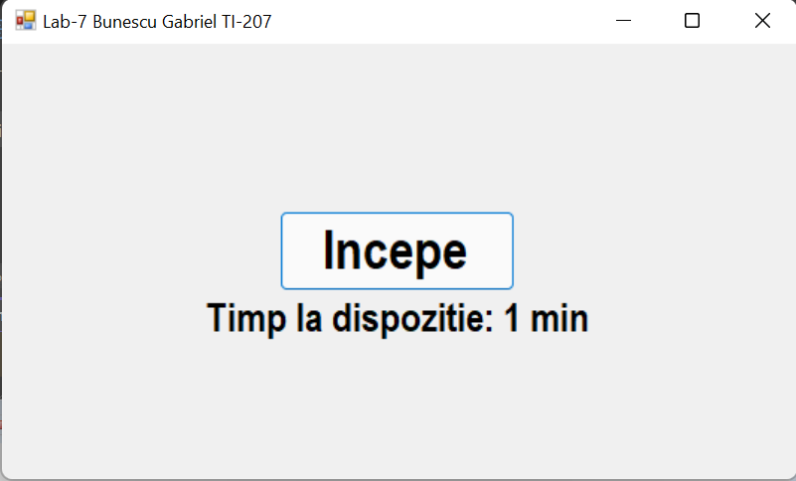

Figura 2. Inceputul.

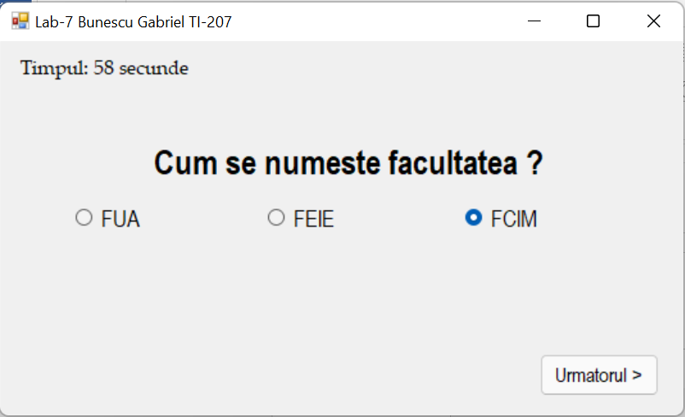

Figura 3. A prima Întrebare.

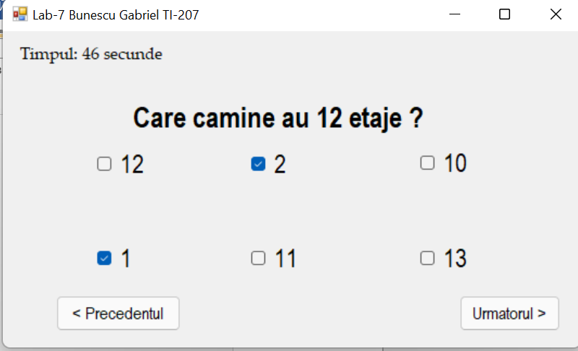

Figura 4. A doua Întrebare.

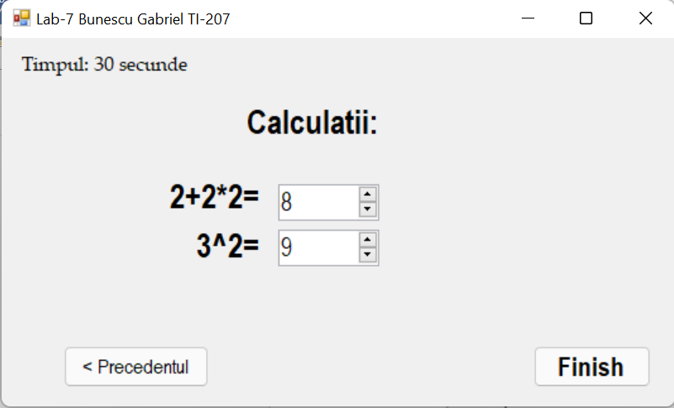

Figura 5. A treia Întrebare.

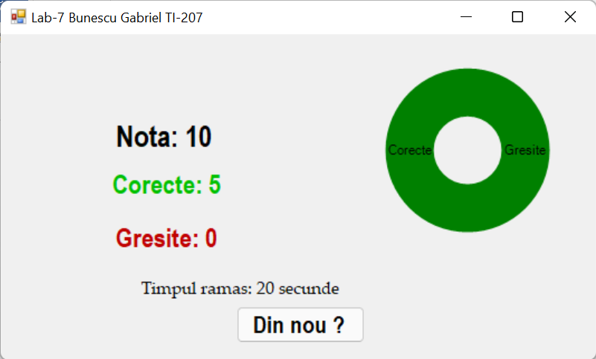

Figura 6. FINISH

**Concluzie:**

În urma efectuării acestei lucrări de laborator am studiat bazele şi principiile de lucru cu timer-ul. Am studiat Limbajul de programare C#, .NET frameworkul pentru Windows. De asemenea , în aceasta lucrare am elaborat un program care afisează un test cu câteva întrebări, utilizând radio butoane, check boxes, butoane push și pentru cronometrare de folosit timer-ul. Pentru afișarea rezultatelor am desenat un grafic în dependență de răspunsuri sau timp.